# **[Azure ML : Python, MLOps &CI/CD](https://www.youtube.com/playlist?list=PL-kVqysGX514KnkdYkSJWqYdJyRWGt899)**

Git : <https://github.com/DeepKnowledge1/azure-ml>

Get subscription id

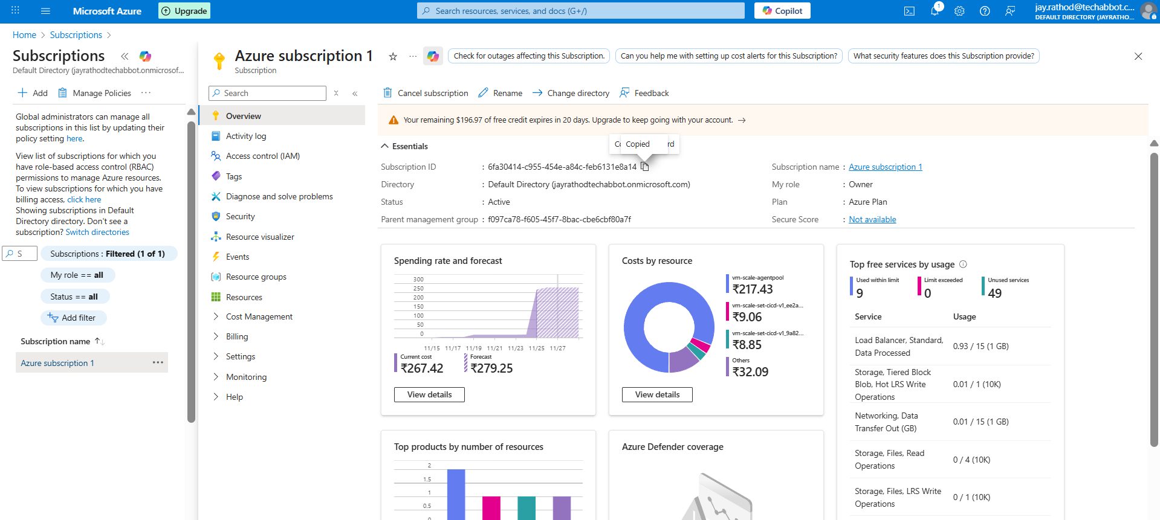

azure-identity

azure-mgmt-resource

argparse

dependency for python SDK

# Create Resource group with pipeline

Create a service connection > Azure Resource Manager

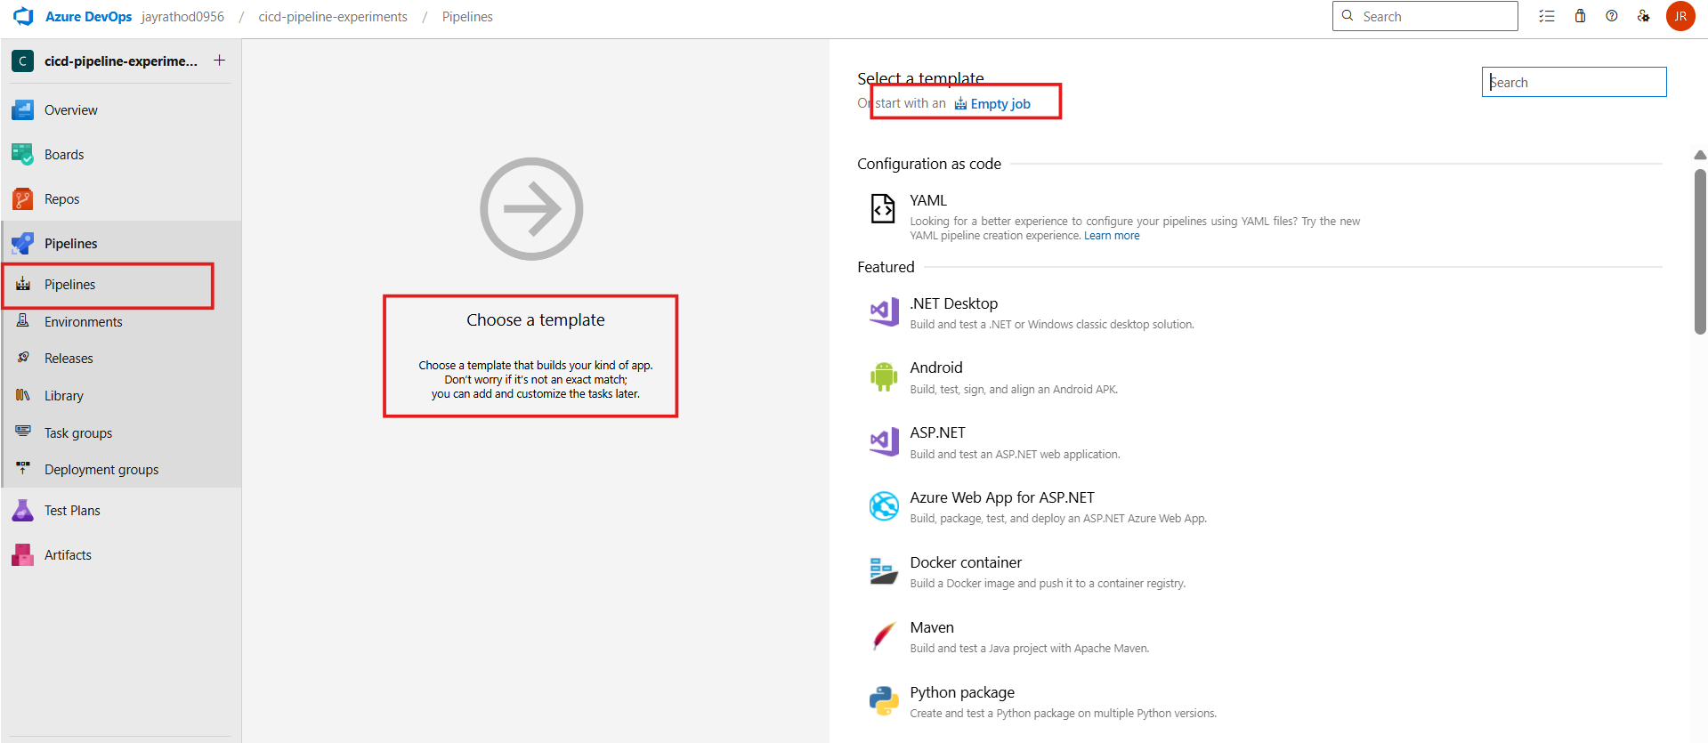

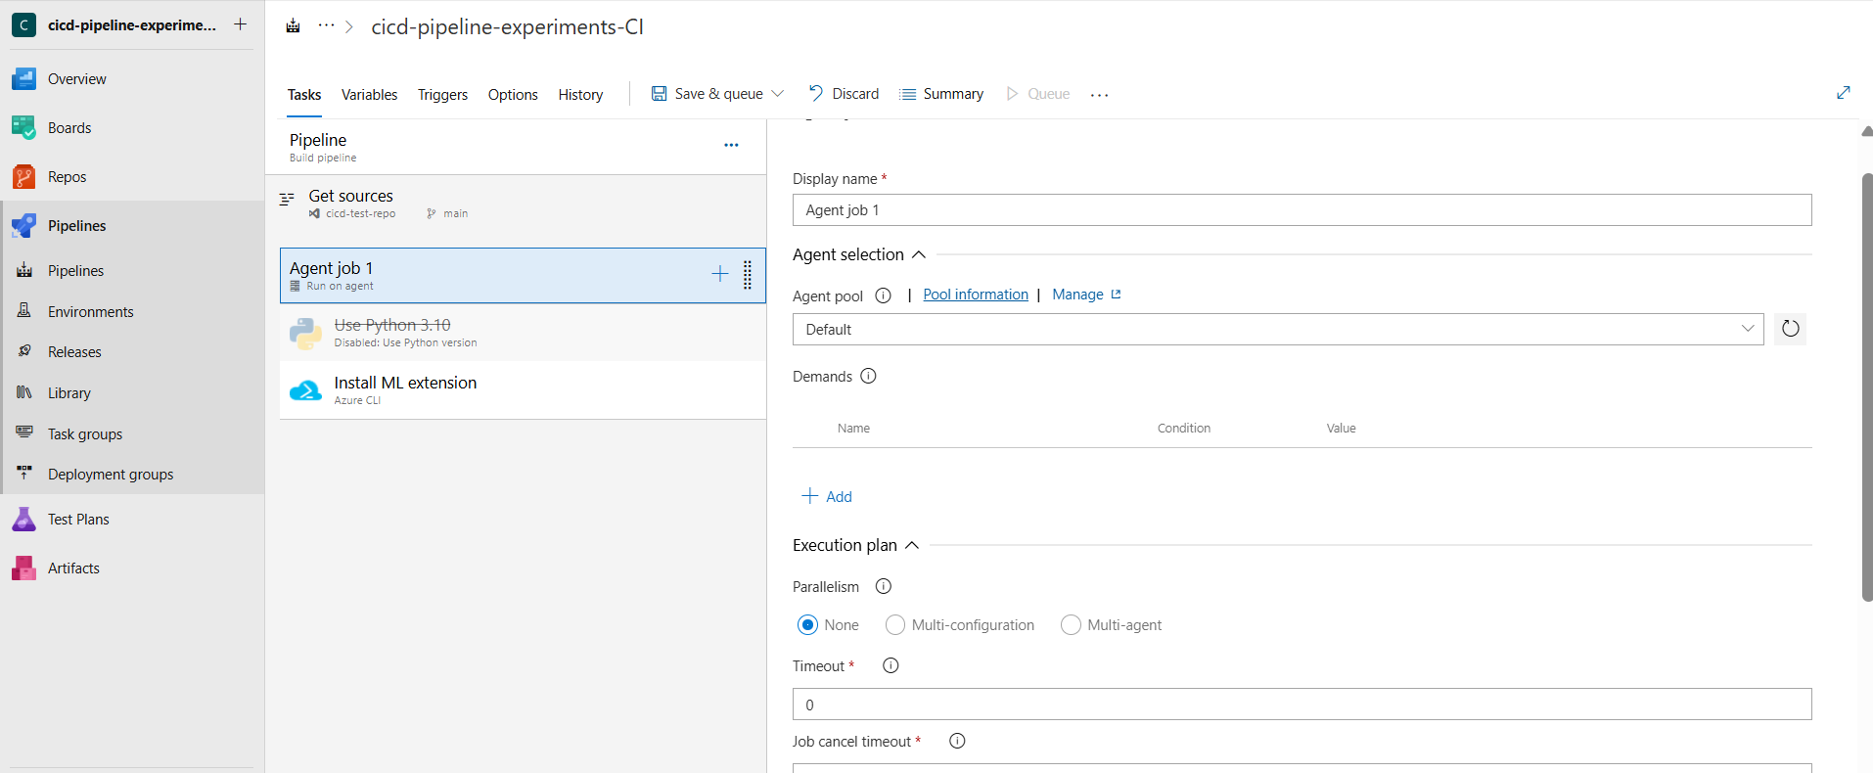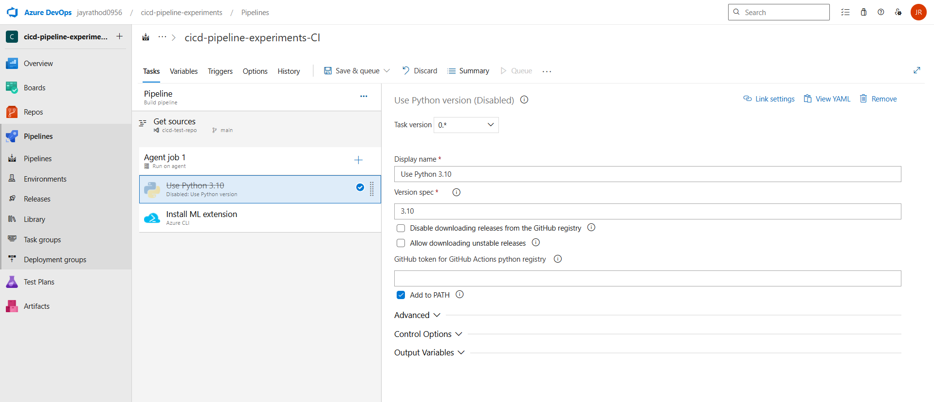

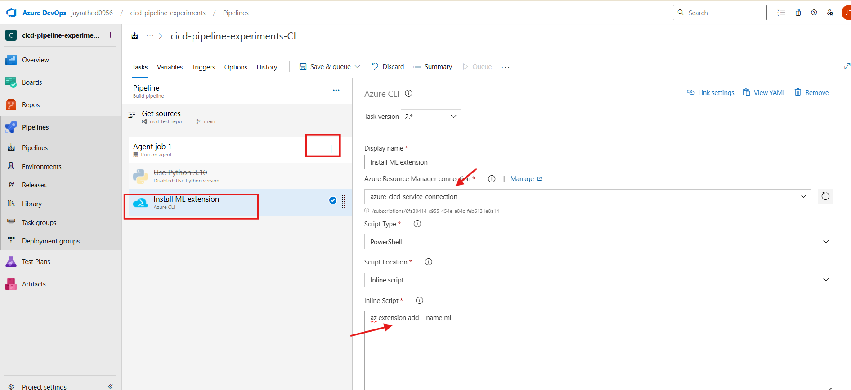

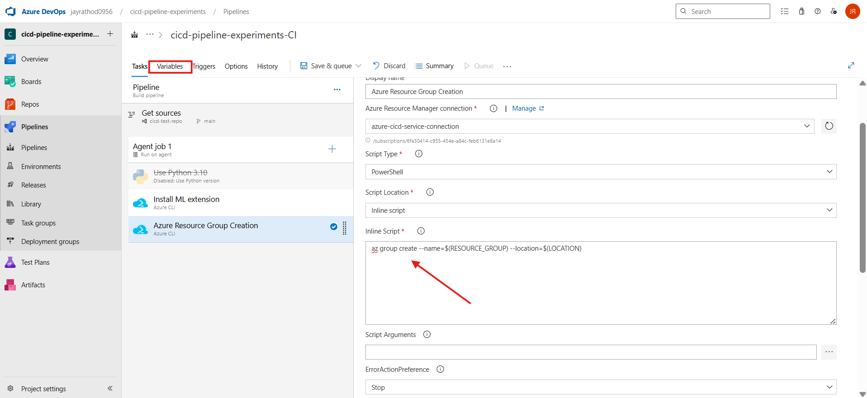

In case of access issue for creating resource group

Add access at the subscription level

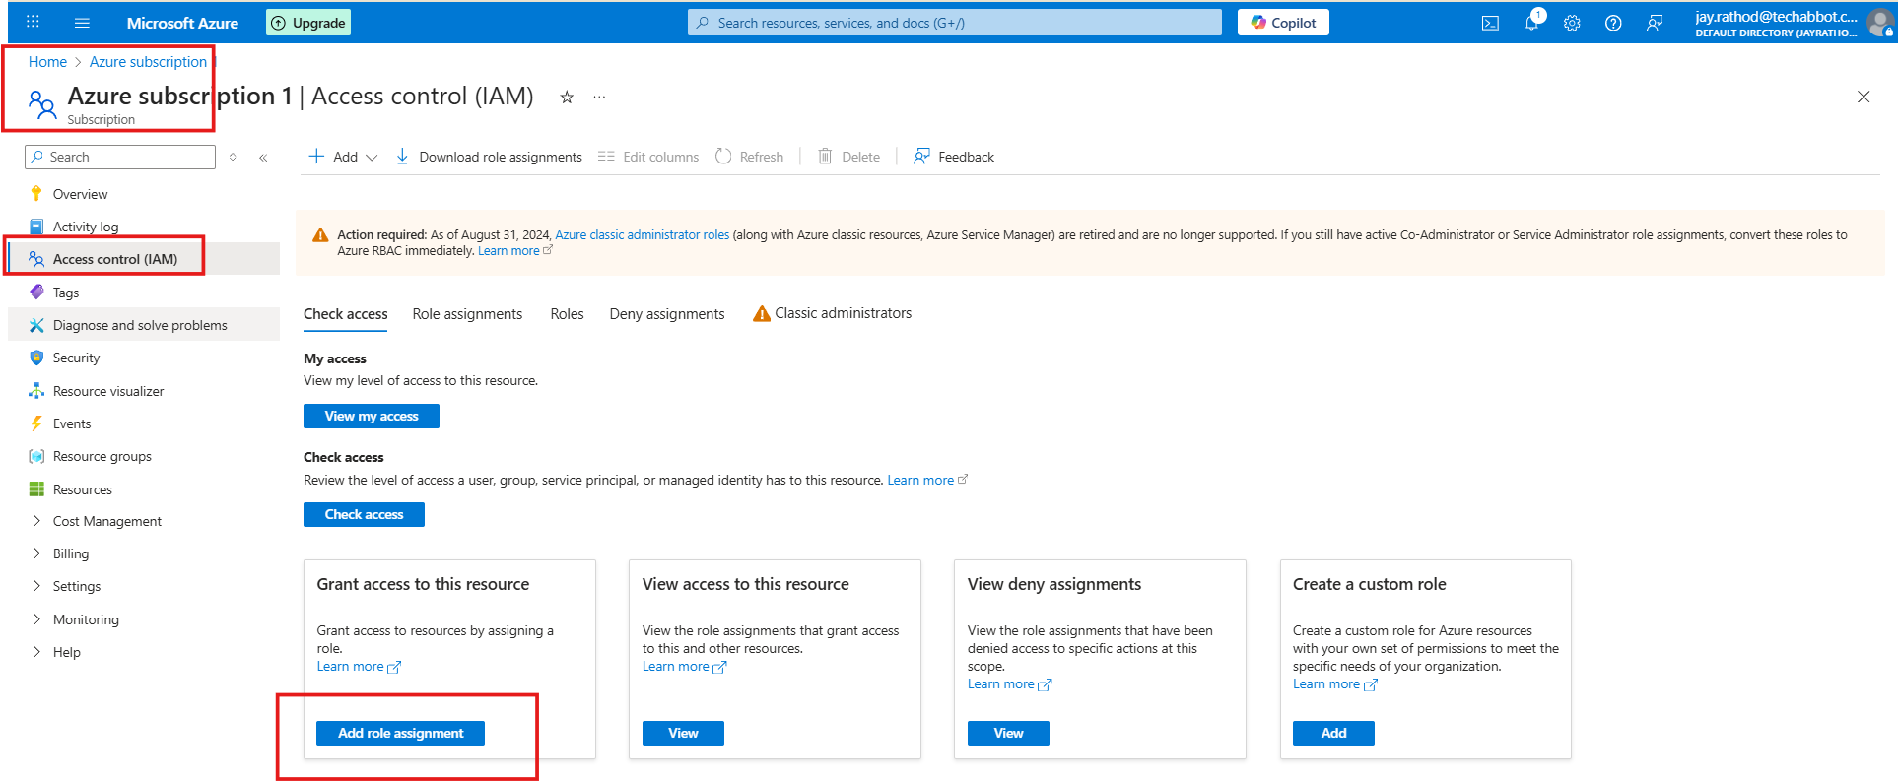

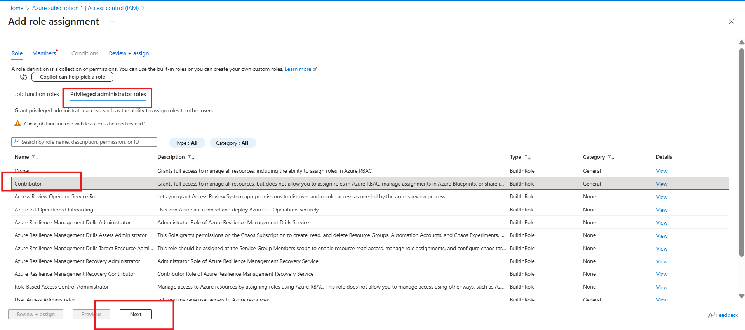

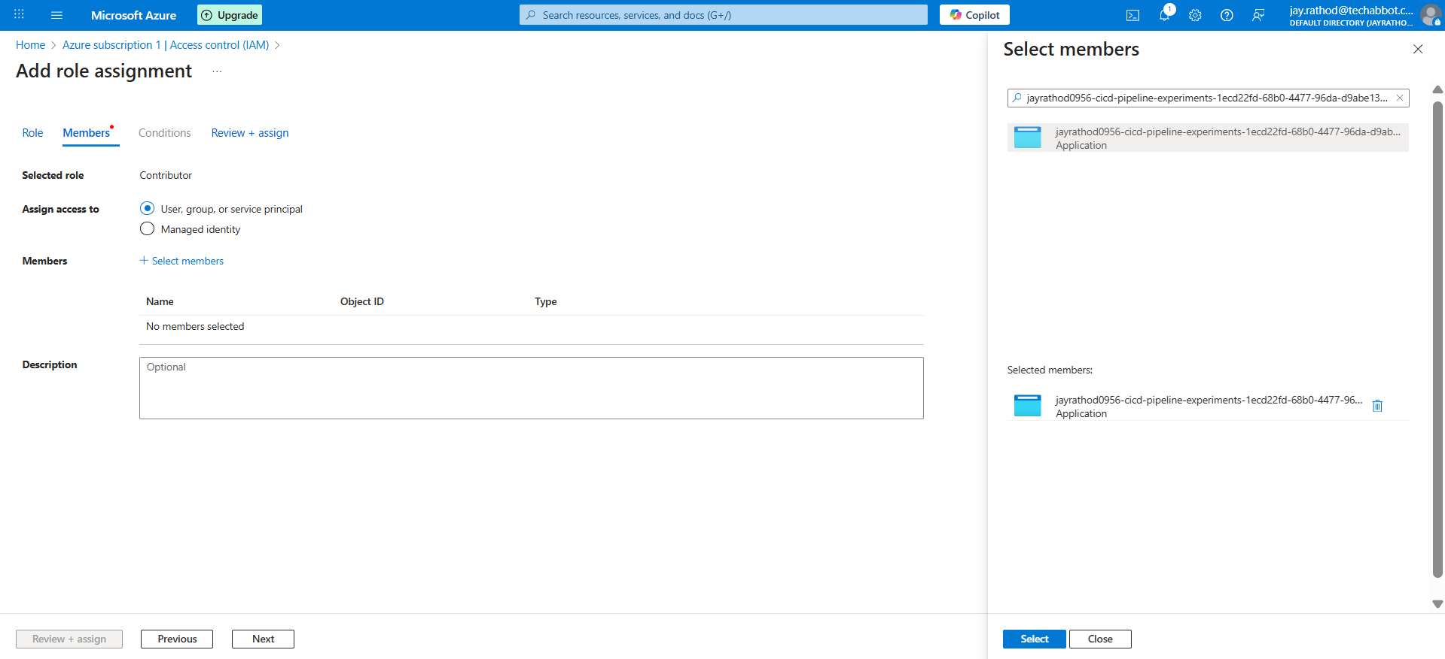

For getting select member follow these steps :

At connection level

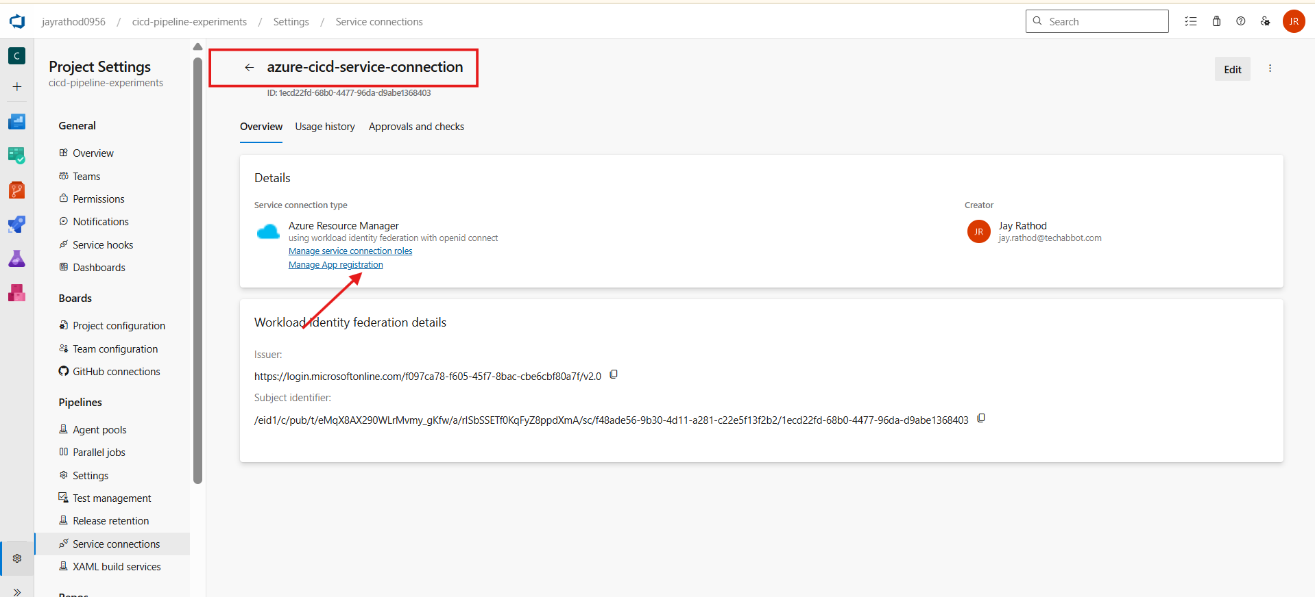

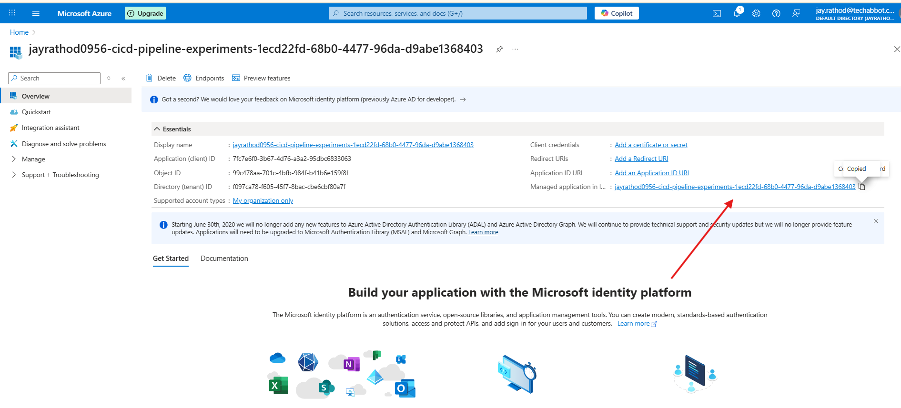

Copy this name and add in the IAM access

# Create ML Workspace pipeline

Powershell local command

az ml workspace create `

>> --name "jay-ai-workspace" `

>> --resource-group "rg-27-ml-cicd" `

>> --location "eastus"

## To get storage key for creating container

$STORAGE_ACCOUNT_KEY = az storage account keys list `

--resource-group $RESOURCE_GROUP `

--account-name $STORAGE_NAME `

--query "[0].value" `

-o tsv

az storage container create `

--account-name $STORAGE_NAME `

--name $CONTAINER_NAME `

--account-key $STORAGE_ACCOUNT_KEY `

--public-access off

account-name = storage account name

## To upload blob from local

az storage blob upload `

--account-name jaystorageaccount2711 `

--container-name jaycontainerv1 `

--file ./data/data.csv `

--name data/fruits.csv `

--account-key <key>

To verify

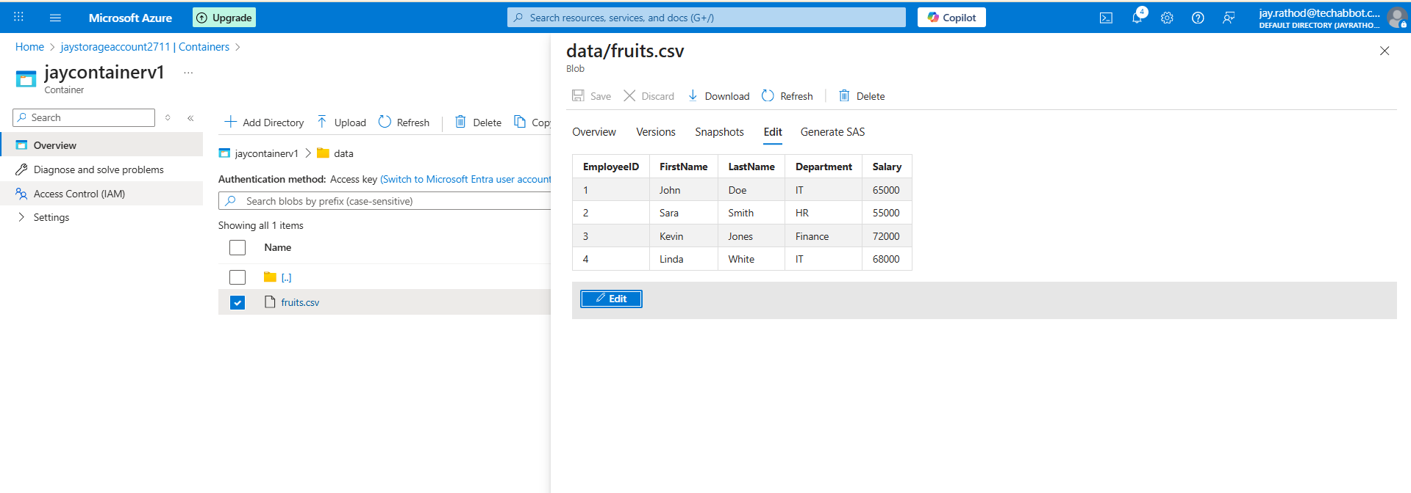

From pipeline

az storage blob upload `

--account-name jaystorageaccount2711 `

--container-name jaycontainerv1 `

--file ./folder/data.csv ` (from repo)

--name data/fruits1.csv `

--account-key <>

--overwrite true

# Create a data store in the Microsoft Foundry

Blob > container > folder > .csv

We need to upload folder

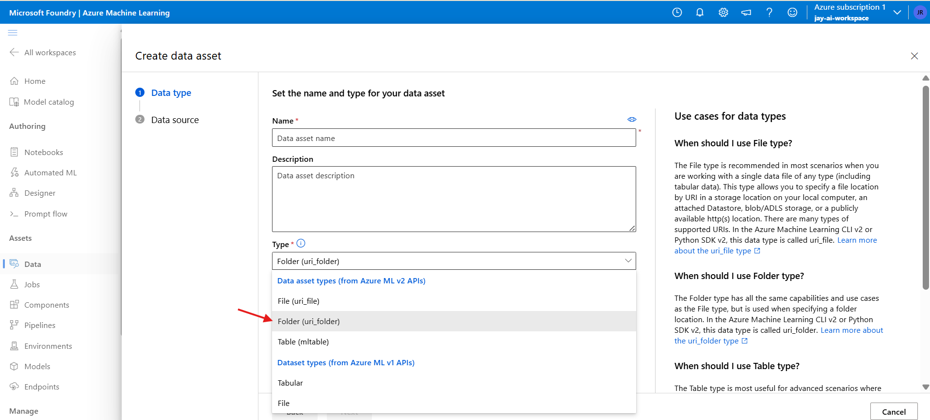

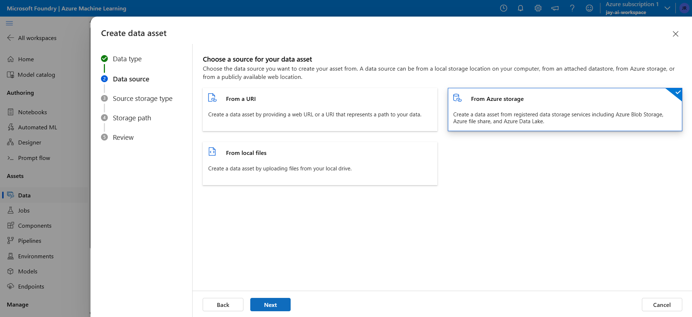

Verify

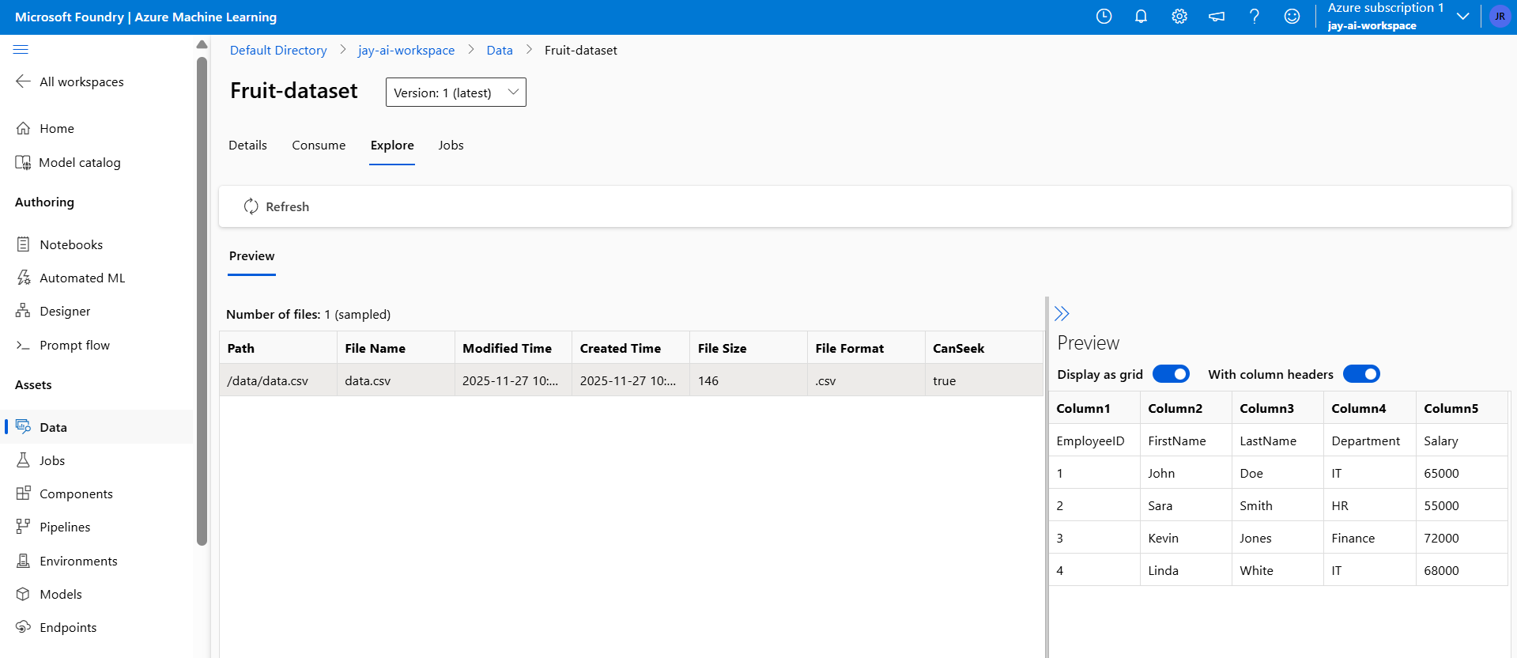

Other way

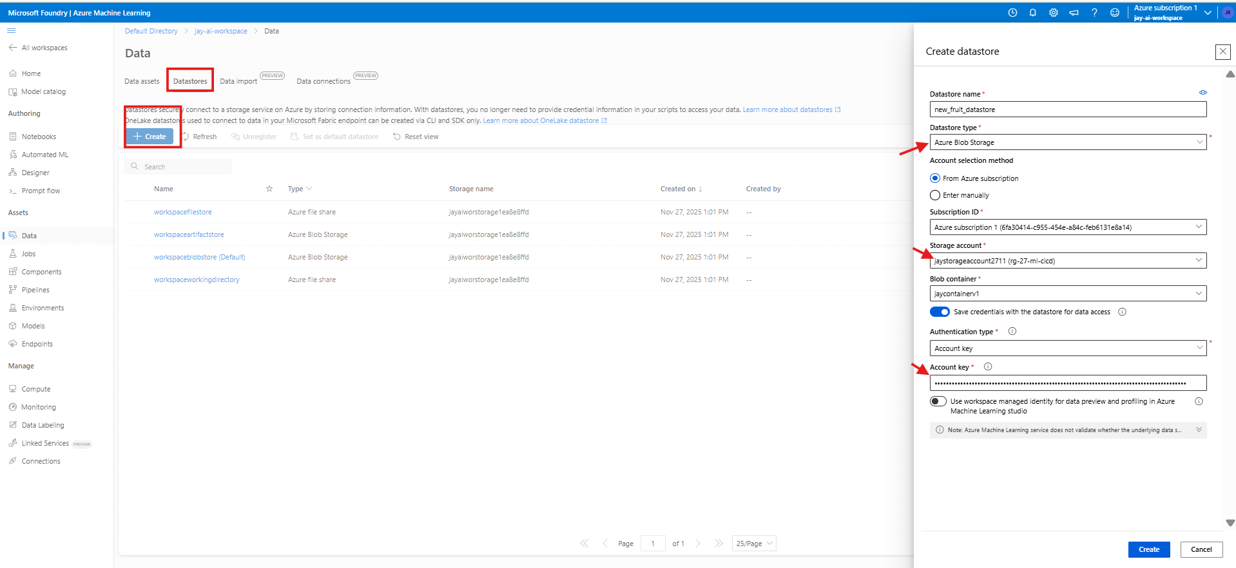

Access key can be fetch from

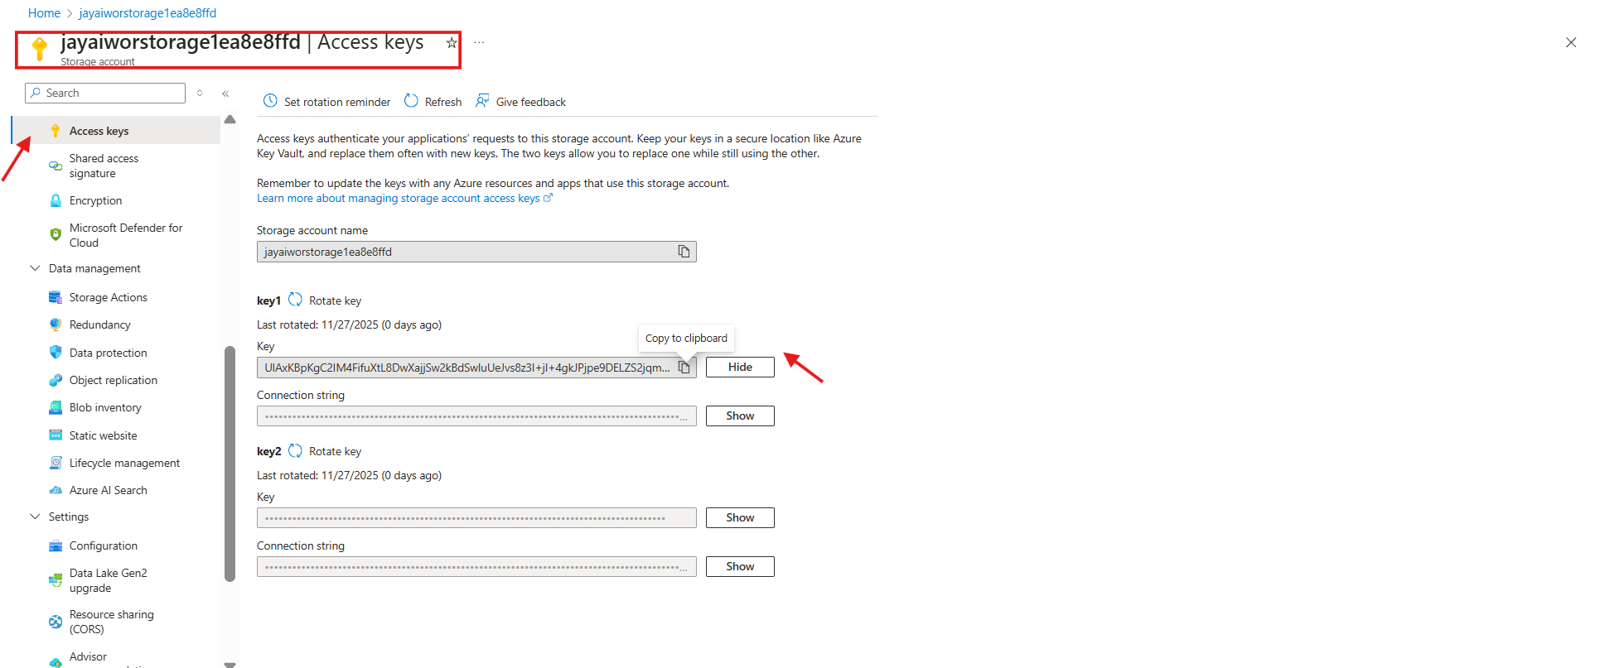

# Issue Not able to access from storage account

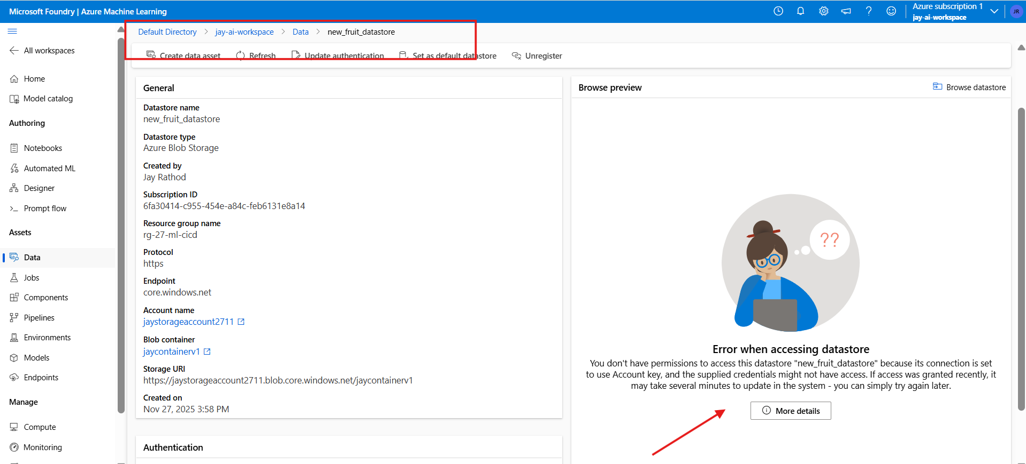

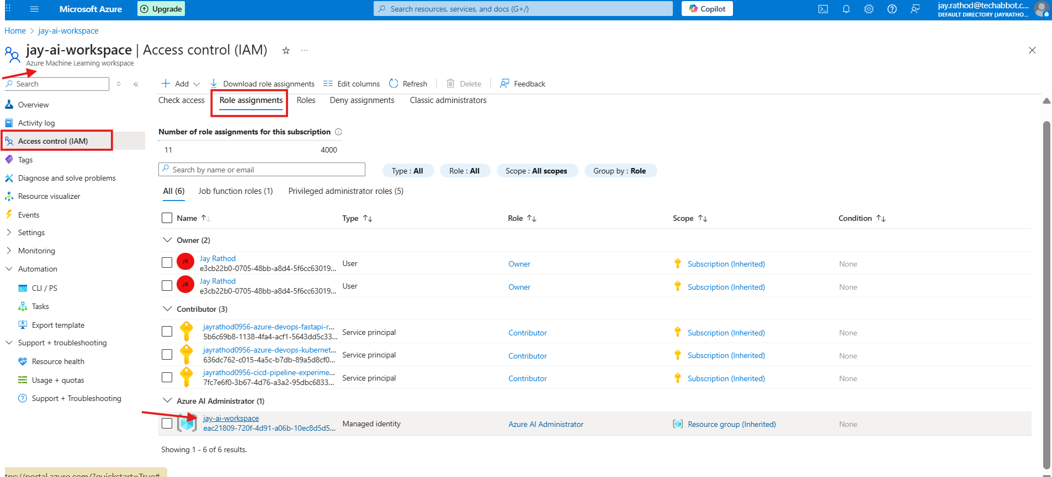

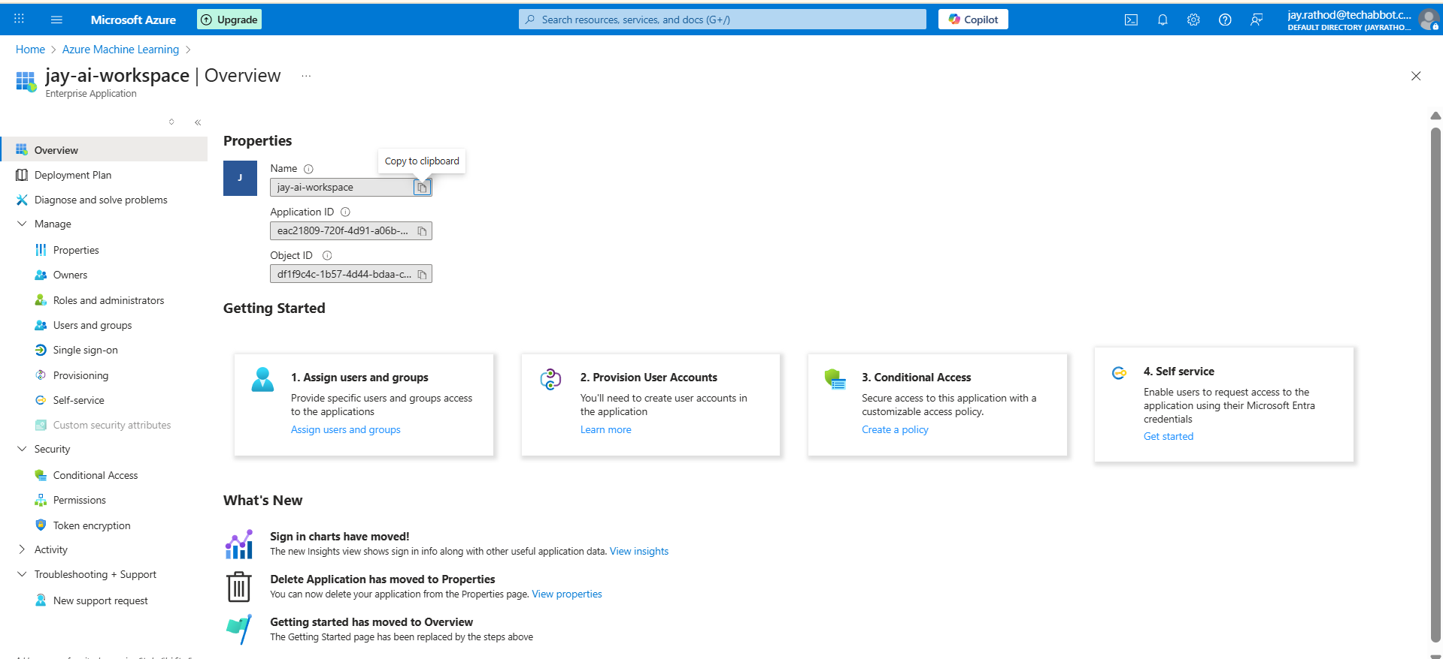

Add inside the access of storage account

# Creating datastore with CLI

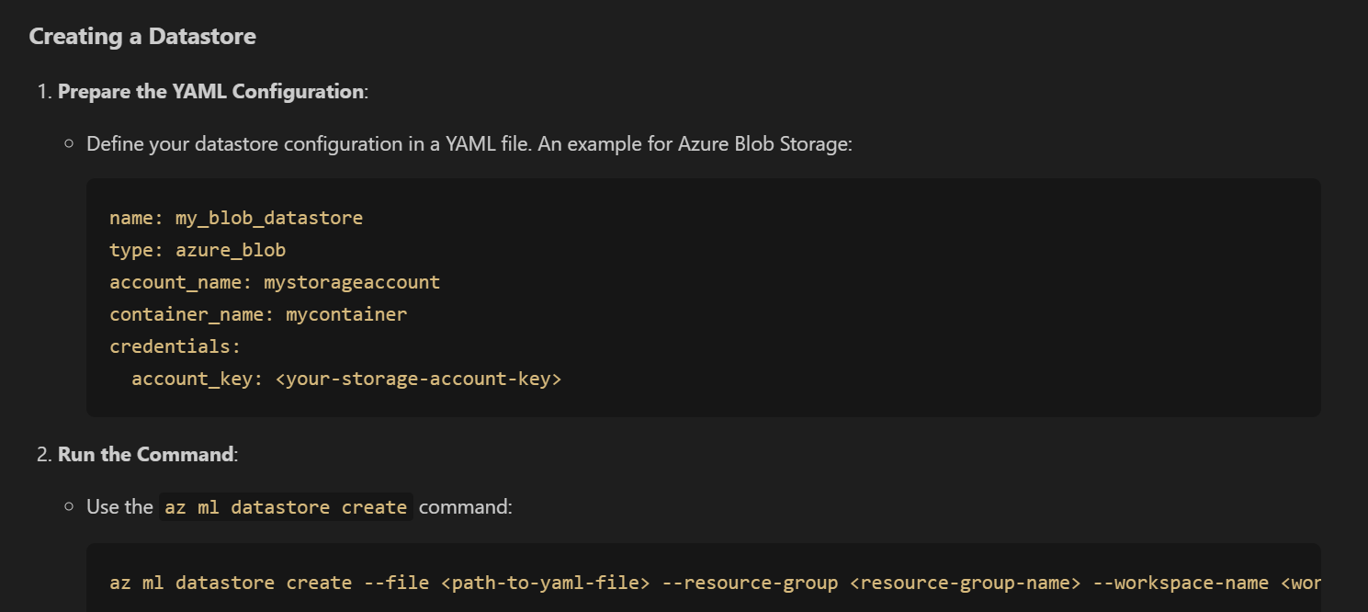

# Create a data asset in the Microsoft foundry

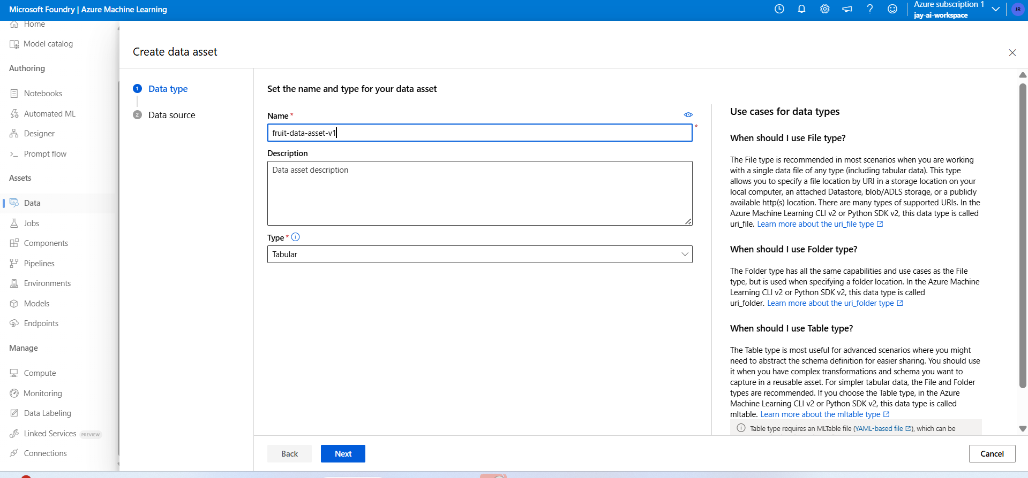

Azure storage + Crete new datastore

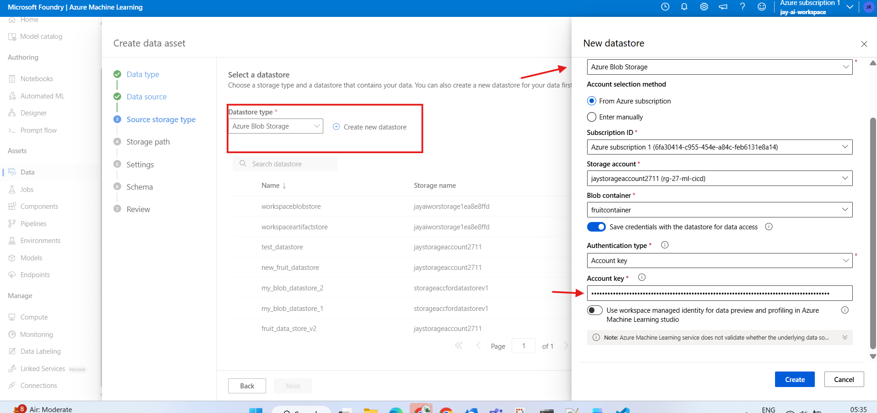

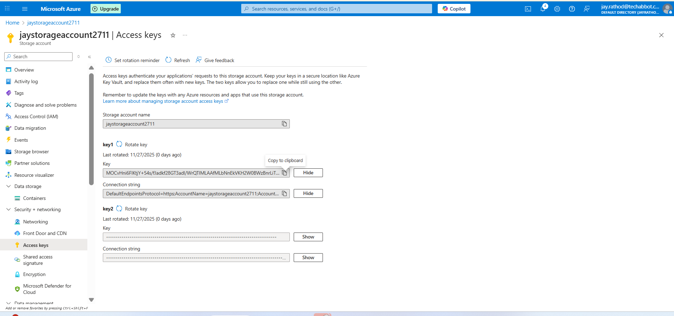

Copy storage key for connection

Selection created data store > select .csv > Next

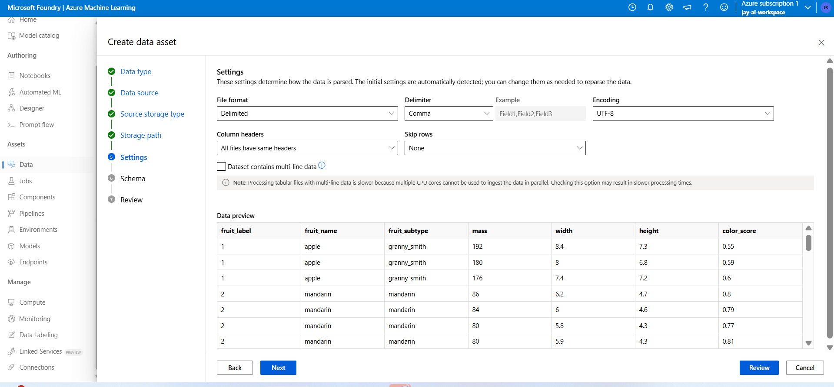

Review > Edit schema

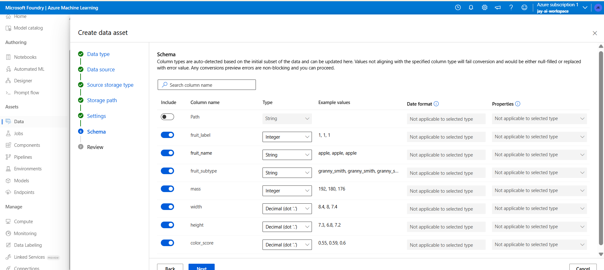

Create

Verify and analysis

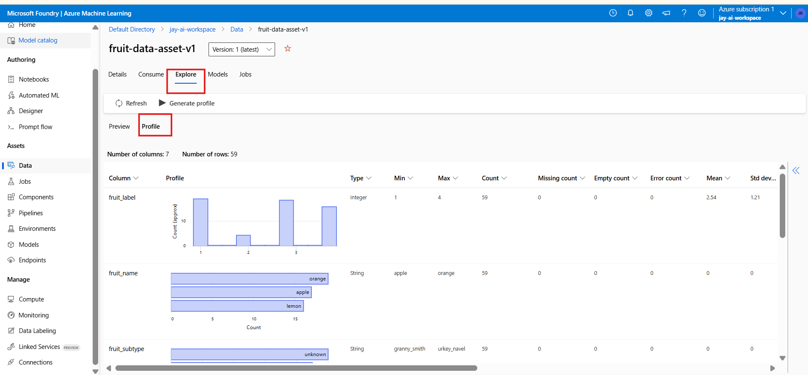

From consume , we can get code

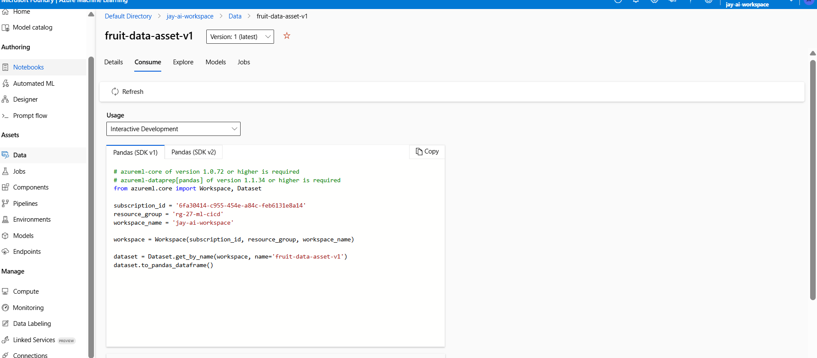

## Data Asset Using CLI from data stores

* To update the version of existing store

Data stores | <any one> | Browse

File name -> three dots -> copy path

azureml://subscriptions/6fa30414-c955-454e-a84c-feb6131e8a14/resourcegroups/rg-27-ml-cicd/workspaces/jay-ai-workspace/datastores/fruit_data_strore_3/paths/fruit.csv

$schema: https://azuremlschemas.azureedge.net/latest/data.schema.json

name: fruit_data_strore_3

version: 2

type: uri_file

path: azureml://datastores/fruit_data_strore_3/paths/fruit.csv

description: "fruits_data_asset data for training"

tags:

  purpose: training

if fruit.csv is inside any folder

path: azureml://datastores/fruit_data_strore_3/paths/<folder>/fruit.csv

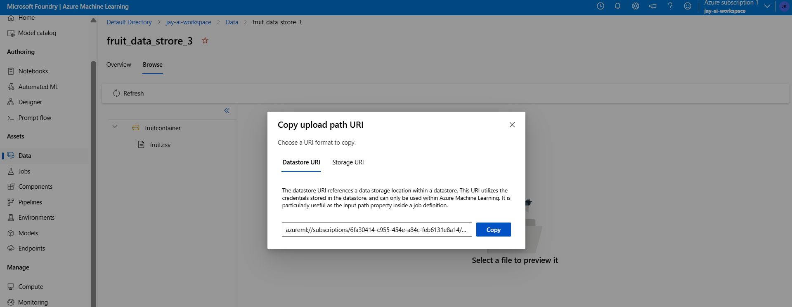

Azure cli command

az ml data create `

--file "./yml_files/data-asset.yml" `

--resource-group "rg_demo03" `

--workspace-name "ws_demo_pipeline03"

Can be verify

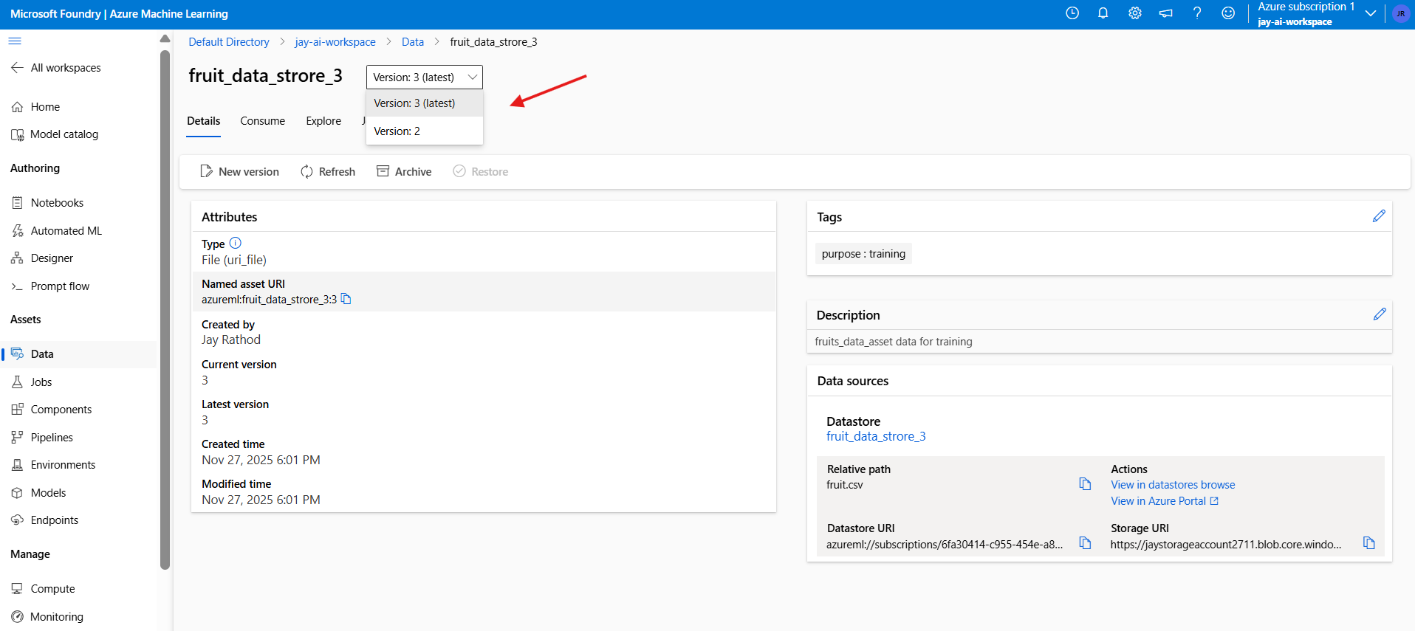

New must have different version/name

# Create Compute

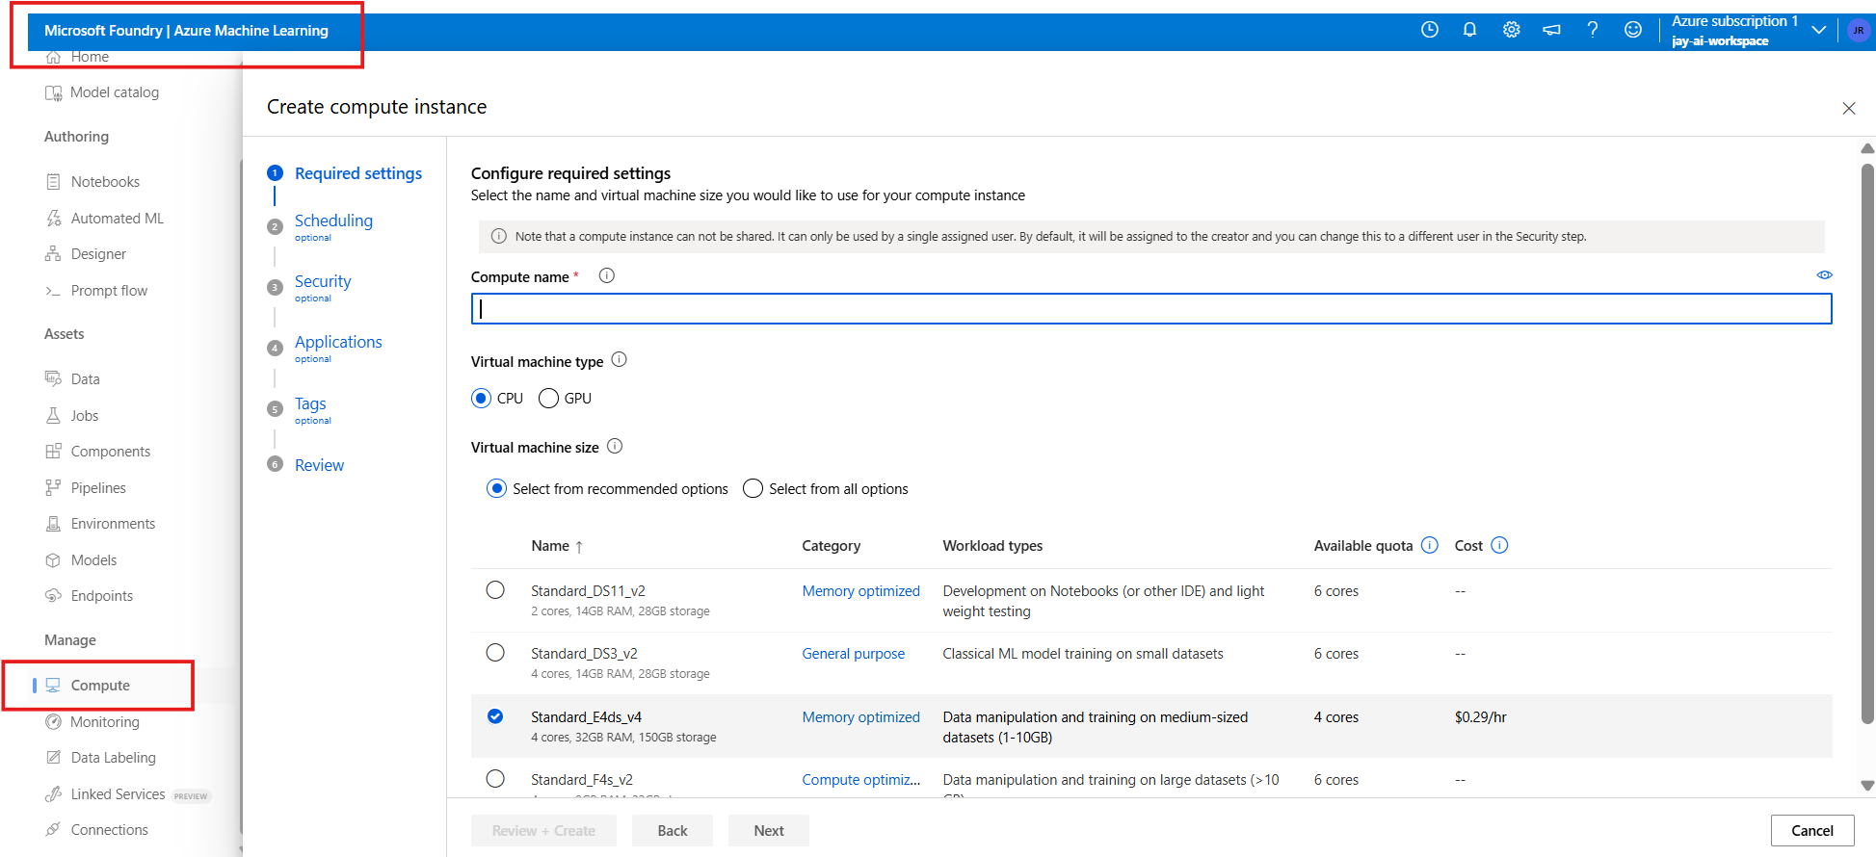

Verify

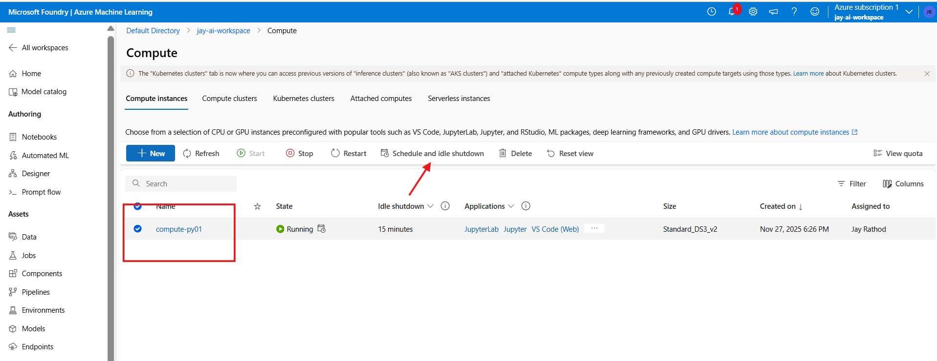

In case of pay-as-u-go option

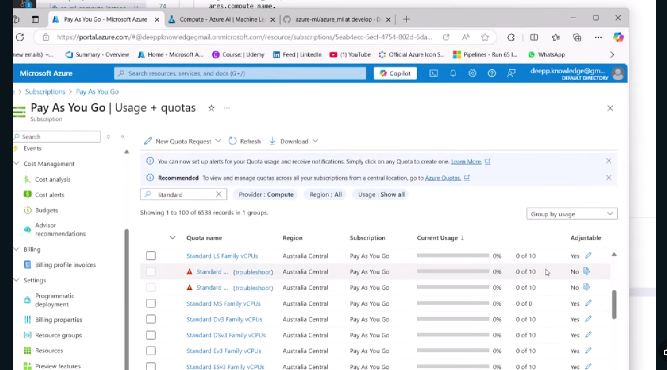

For distributed training -> Go for Compute-cluster

# Run Model pipeline on the compute-cluster

Created a cluster named “[compute-cluster-cli01](https://ml.azure.com/compute/compute-cluster-cli01/details?wsid=/subscriptions/6fa30414-c955-454e-a84c-feb6131e8a14/resourceGroups/rg-27-ml-cicd/providers/Microsoft.MachineLearningServices/workspaces/jay-ai-workspace&tid=f097ca78-f605-45f7-8bac-cbe6cbf80a7f)”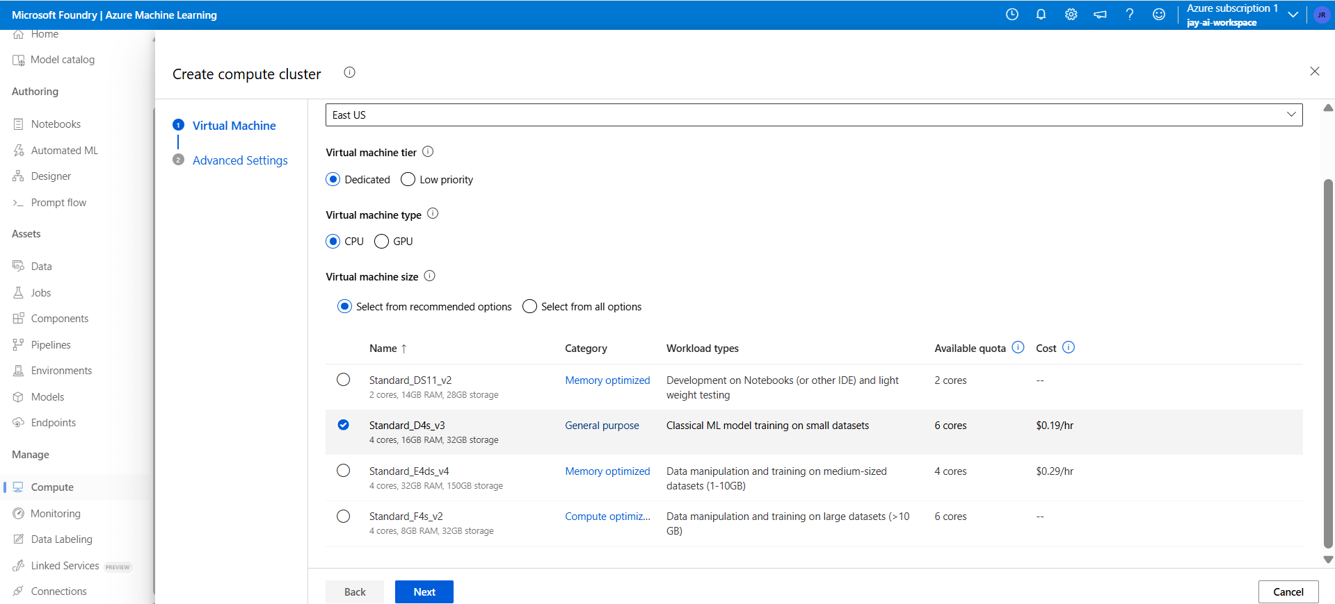

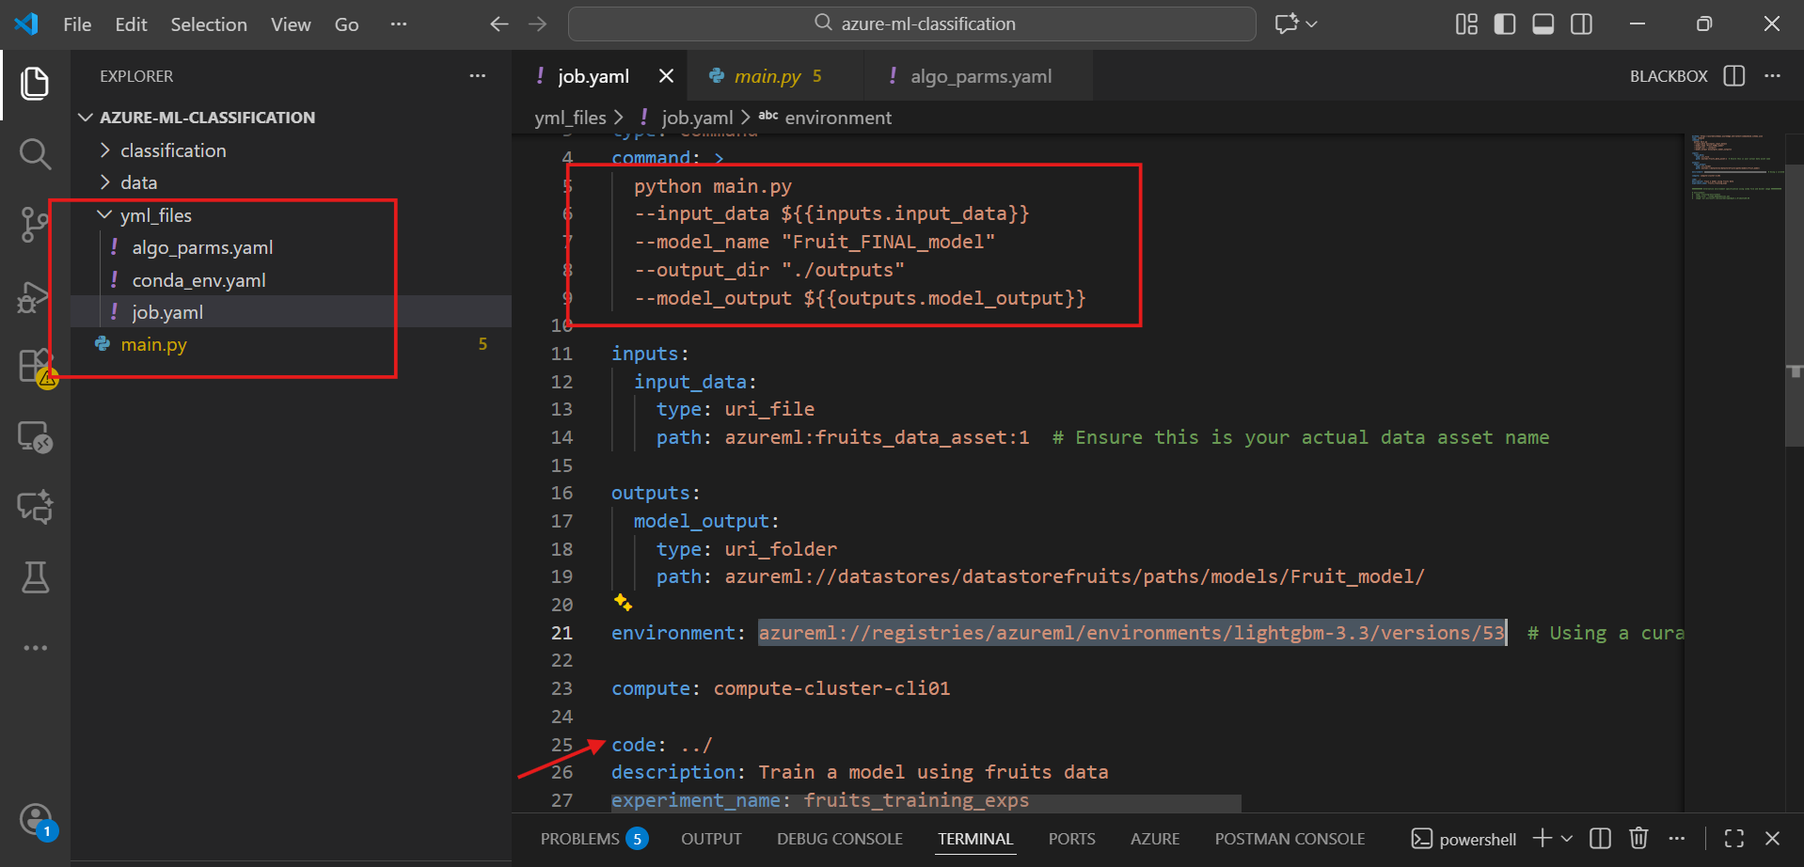

Code defined the starting point

Command defined what to run on the cluster and in which order

Define the data asset

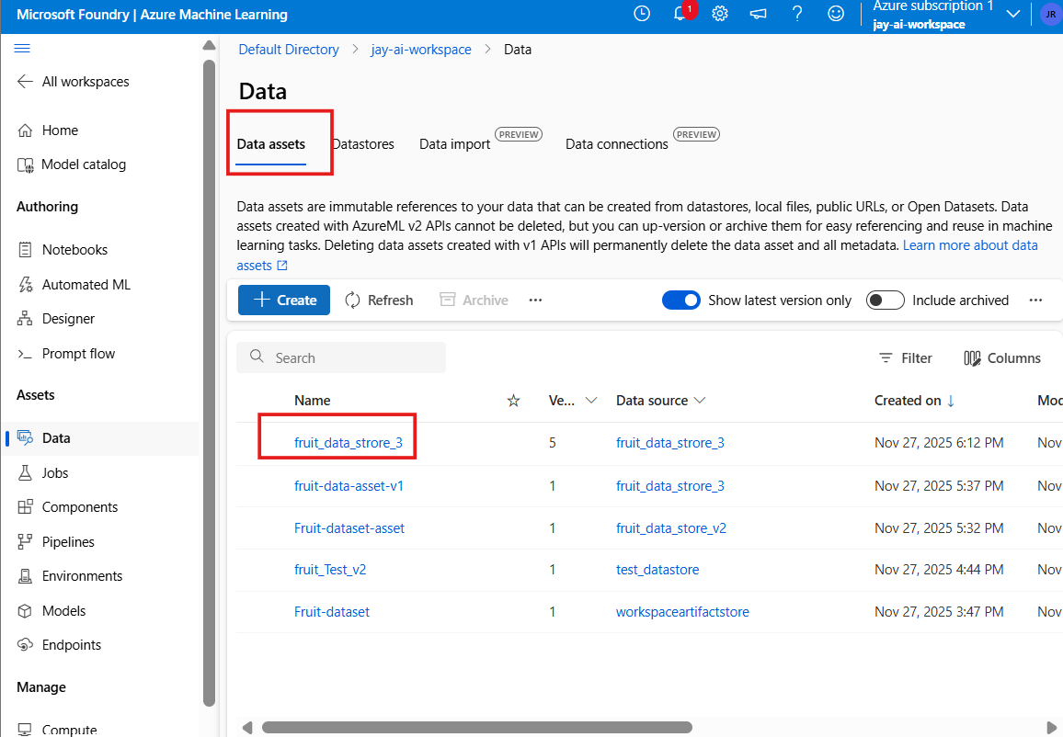

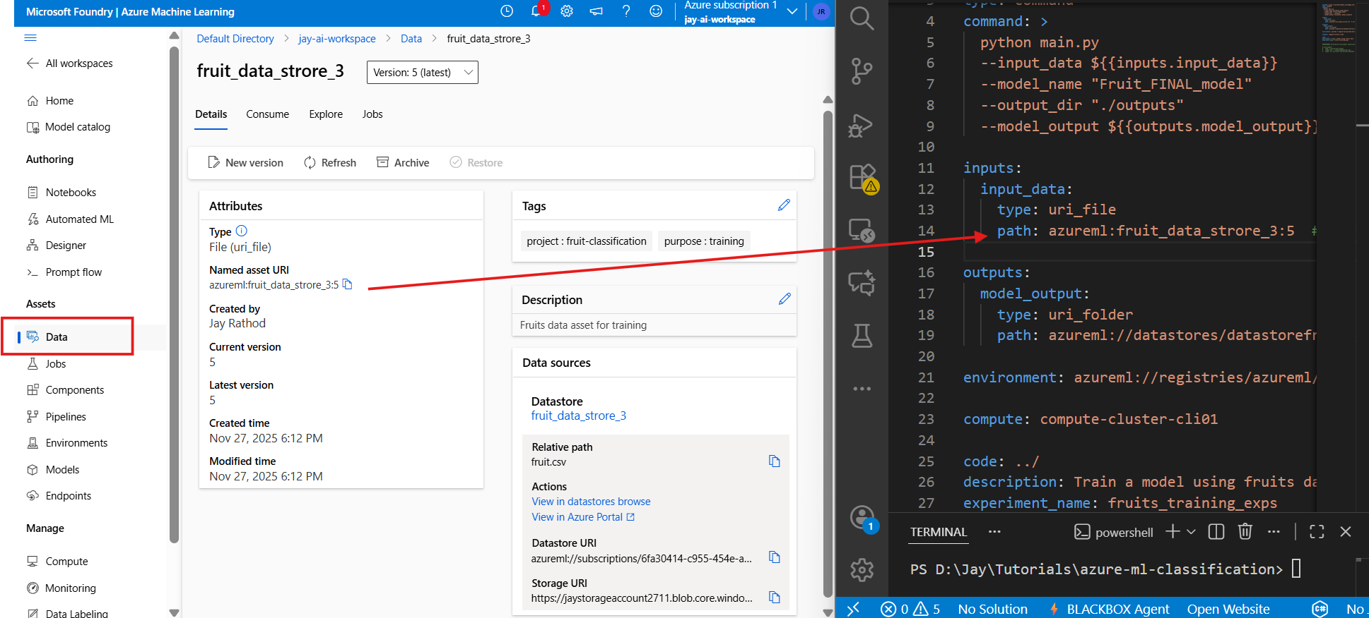

Out put path : path: azureml://datastores/fruit_data_strore_3/paths/models/Fruit_model/

Select env for dependency

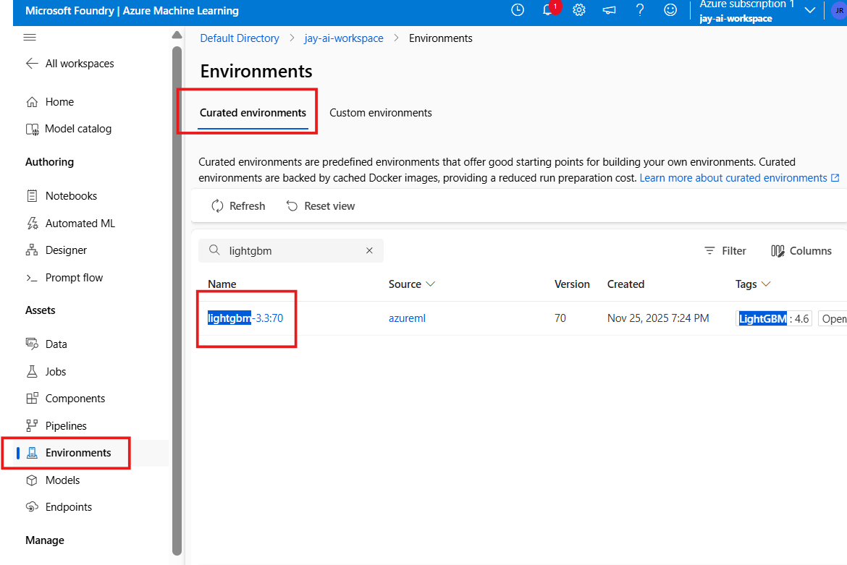

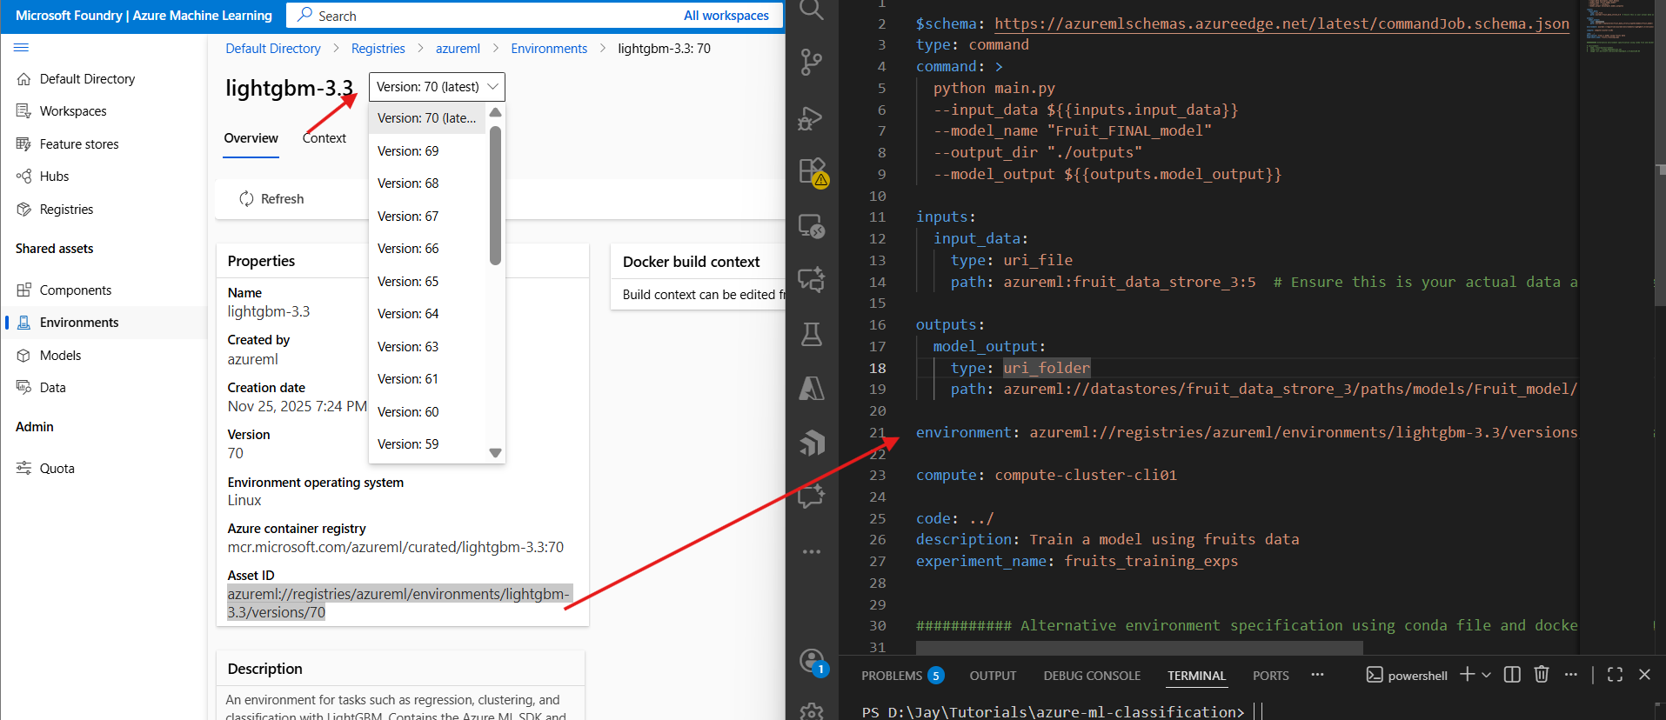

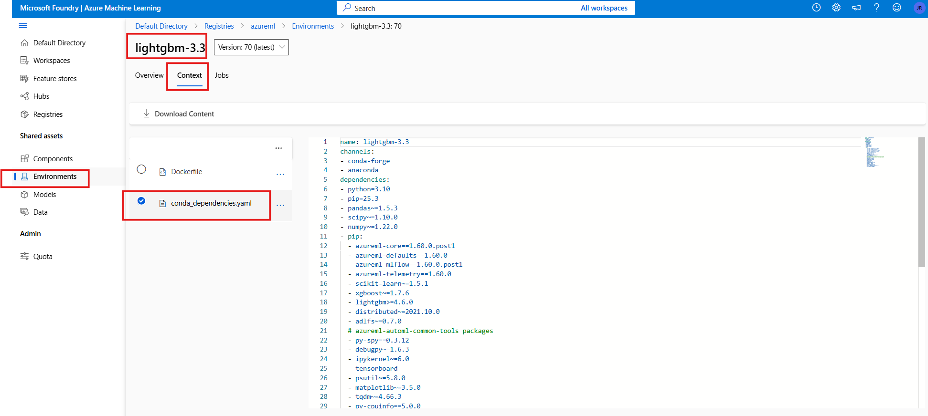

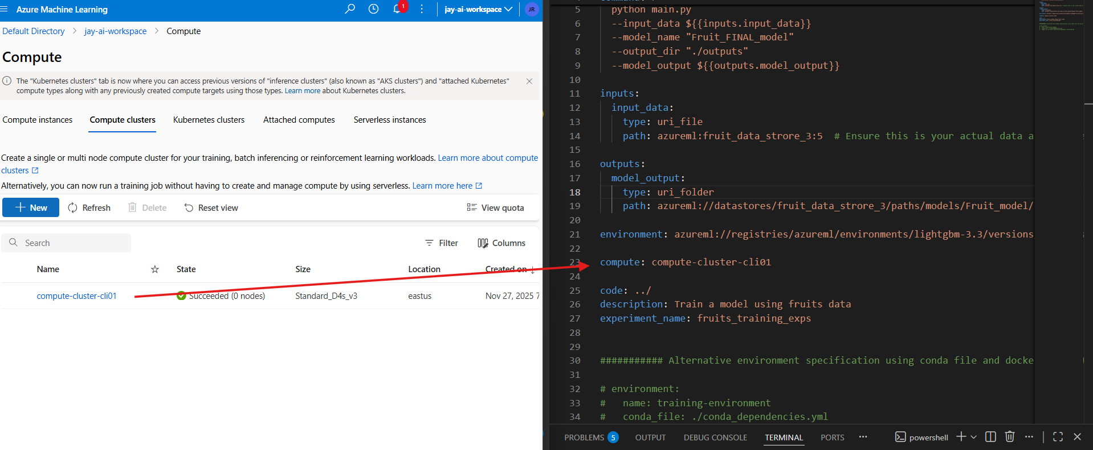

az ml job create `

--file "./yml_files/job.yaml" `

--resource-group "rg-27-ml-cicd" `

--workspace-name "jay-ai-workspace"

After training

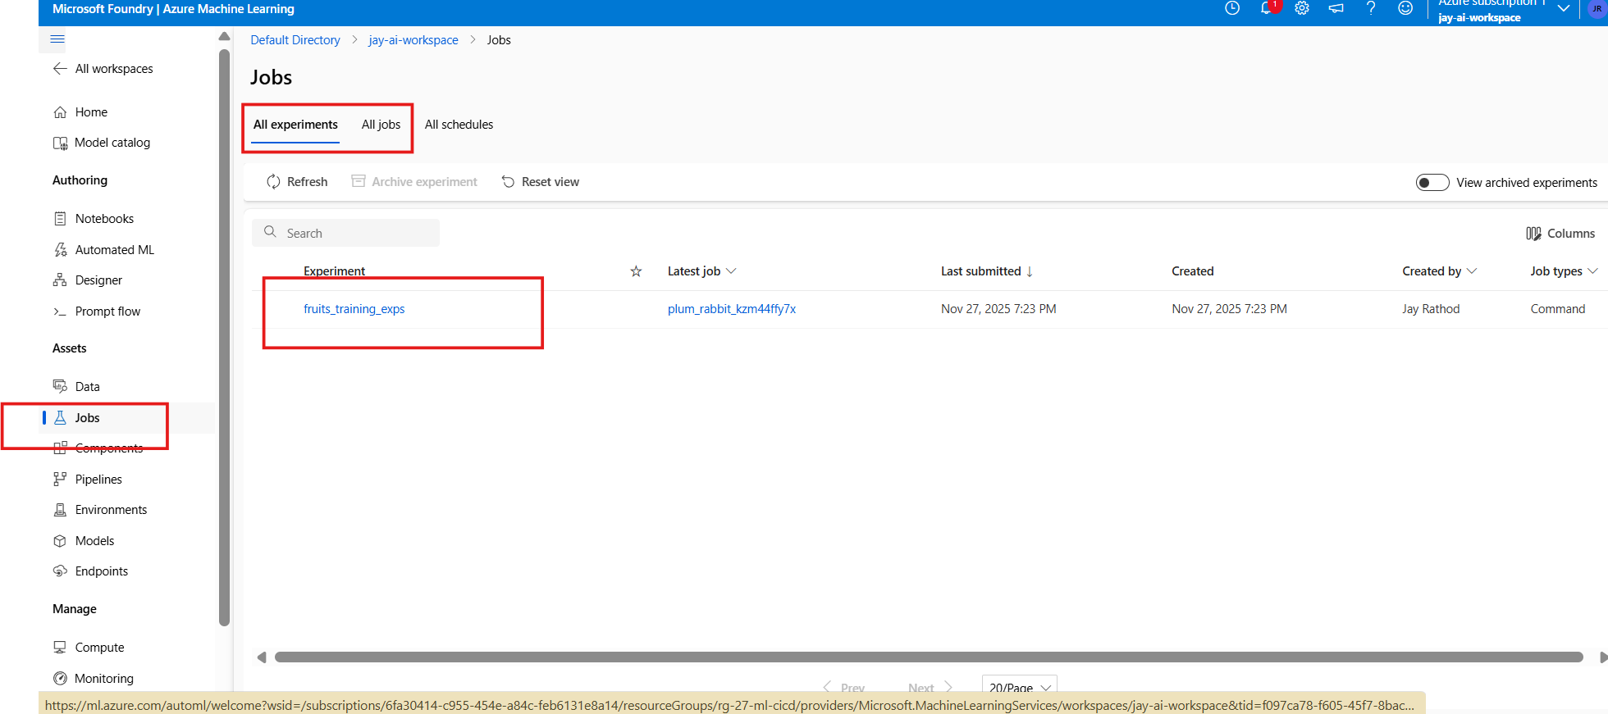

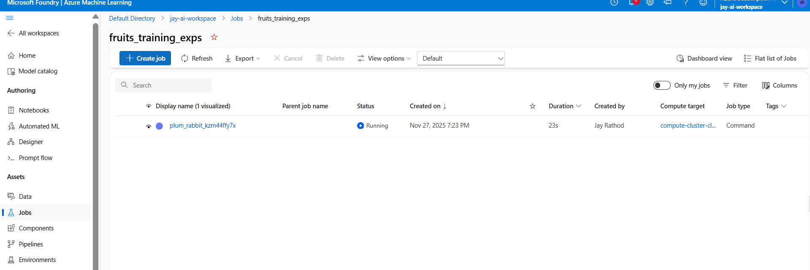

ML table issue